3D Concepts Ephemeral Art Assignment
Use pmhsartstudio.weebly.com “more” “links” and “Goldsworthy sculpture” to find links to the presentation and this worksheet so you don’t have to type in web addresses!

Vocabulary:
Elements of art: line, shape/form, value, color, size, space, texture
Principles of design: contrast, unity, variety, rhythm, movement, dominance, balance
Ephemeral- temporary, transient, fleeting, doesn’t last very long

Andy Goldsworthy is an artist who goes out into nature and creates ephemeral artwork from the natural materials he finds at the sites he creates the art in. Ephemeral means that the art doesn’t last for very long- it blows away, washes away, or falls apart after it is created. He doesn’t use any glue or nails to hold his work together! Only things found in nature on site. Goldsworthy photographs his pieces, does sketches of them, and even writes poetry about the sculptures he creates.

Watch this trailer of Rivers and Tides, a documentary about Andy Goldsworthy:
https://www.youtube.com/watch?v=LrGMkXukeEo

Here’s a collection of some photographs of his work, take a look:
https://www.boredpanda.com/land-art-andy-goldsworthy/?utm_source=google&utm_medium=organic&utm_campaign=organic

Andy Goldsworthy sketches of his work:
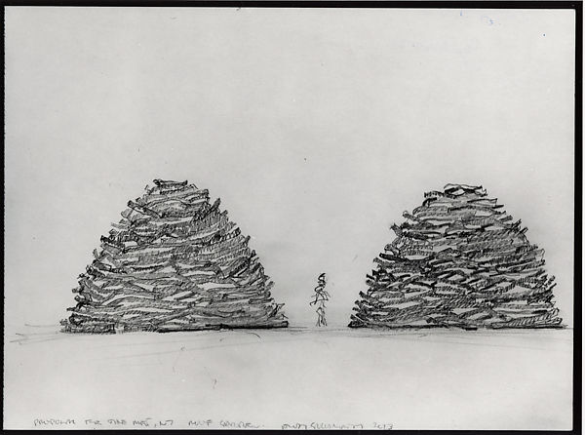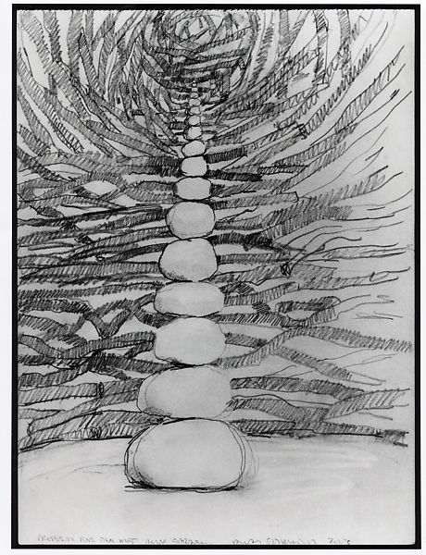

Your task:
Create an ephemeral work of art using only what you find in an outside location of your choice. You can take a walk (or a drive if you can) to a park, use your own backyard, or even a small patch of grass you find. As long as you have a few natural materials and creativity, you can create something beautiful. Create a sculpture from natural materials in the location you choose. You may use anything naturally occurring- sticks, leaves, grass, flowers, rocks, moss, etc. but nothing man made and certainly no glue or nails! Focus on your use of elements and principles- how can you use line, shape/form, color, value, and size to create balance, contrast, rhythm, variety, or dominance? When you’re finished, take a photo of your sculpture if you have access to a camera. Do a quick sketch of your sculpture as well. Then answer the questions below about your sculpture.

Requirements:
- a photograph of the sculpture if you have access to a camera sent to krista.staton@bvcps.net
- a sketch of the sculpture regardless of if you were able to take a photo on any paper in pencil
- answer the questions below

- Title your sculpture:______________________
- What materials did you use?

- Describe your sculpture in 3 complete sentences.

- What inspired you to create the sculpture?

- What challenges did you face when creating your sculpture? (wind? Getting things to stack/stick together/bend, etc?)

- What elements and principles are present in your sculpture? (see list above)

- Describe how one element or principle is present in your sculpture.

